For my doing assignment I prototyped an alternate version of the alarm clock interface on an android phone. I wanted to see if changing the alarm visual arrangement could make finding and changing alarms more intuitive and less of a cognitive burden. Here is an example of the main screen.

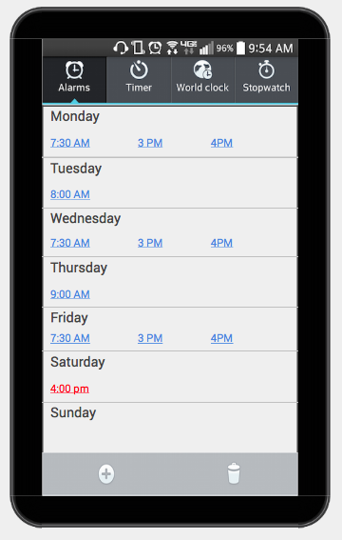

For this prototype I used justinmind which can be found at [www.justinmind.com](http://www.justinmind.com)

This test generally produced better results from the original design and all three users stated that they would prefer this lay out to the original. Finding times and schedules for specific days was much faster. However, using a screen similar to the original editing screen was problematic. Some users had problems figuring out the difference between turning an alarm “off” and deleting it when the alarms are presented in this format. Some larger changes to the alarm edit screen will be required.

-Calvin Hicks